**Setup Document**

Course: **ProP**

Group: **12**  
Names: **Subhi Hamidi  
 Ryan Hermelijn  
 Mohammad Baghban Haghighi  
 Gael Shema**

Date: **08-11-2018**

Teacher: **Matthijs Kuiper**

Version: **2.3**

Table of Contents

Contract 3

Processes 5

Functional requirements 7

For Website 7

For C# application 8

GUI 10

Wireframe 12

ERD 16

# Contract

Agreements

**ENGAGEMENT:**

The company(StageBrite) hereby agrees to engage our company(SuMoRyGa Solutions) to provide a software solution for the HighLand Halloween Festival event that will take place. The service shall be provided by (SuMoRyGa) in form of three full-fledged applications namely ; a Desktop application , a website for the users and and an Android Application .

The applications will all take a period of 6 months for completion and delivery upon which any delay (if any) will be communicated to the client 2-3 weeks in advance.

It was also the client’s wish that we run some form of advertisement on the website from which Facebook was identified as a perfect platform from which to run our ads.

The applications will all be only in English since the target audience is mostly foreigners.

The event will go on for 3 days , however its the client’s wish that the applications developed be expandable as he would like to use them for future events of the same kind or so.

Finally a budget was set at 50.000 euros including billables and development work for the applications upon which an extra amount can be discussed should the funds run empty ; however it also holds certain ramifications in the future.

**Engagement Overview:**

1. **Website:**

The website will mainly be used by the event-goers to get information about the

event, consult the schedule, buy tickets, check their balance via a dashboard

dedicated to them(individuals ,groups or VIPs) and cancel their tickets if wished to.

1. **Desktop Application:**

The desktop application will mainly be for sellers at the event , for selling tickets ,

commodities, loan out materials,among others.

1. **Android App:**

This will mainly be for the client to overview revenue.

DISCHARGE

The Formal Client:

I, ………………., the formal client of this project; accept the fact that I have agreed on all of the deliverables1 and on the deadlines1 and confirm that all of the costs and fees will be fully paid by me. I also accept that I will close any other contracts related to this project.

This serves as confirmation that the last and final results have to be transferred to the project agreement.

If there are still any other uncleared details or issues, notify Mr. Mohammed as soon as possible. We appreciate your service and we are looking forward to serving you again. we seek your concurrence!

I, the undersigned, confirm that the above mentioned facts are true and correct and i give the

permission to start the project.

Name: _________________________

Signature:______________________

Date:___________________

The team leader :

I, Mohammed Reza Baghban Haghighi and the rest of the team whose information comes below, accept to deliver all of the required deliverables on time and to use the available budget wisely.

Project Leader:

Mohammad B. H.

------------------------

team members:

Subhi Hamidi Gael Shema Ryan Hermelijn

-------------------- -------------------- ----------------------

# 

------------------------------------------------------------------------------------------------------------

1. As mentioned in the Project plan And Setup Document.

# Processes

In the **C# Application**:

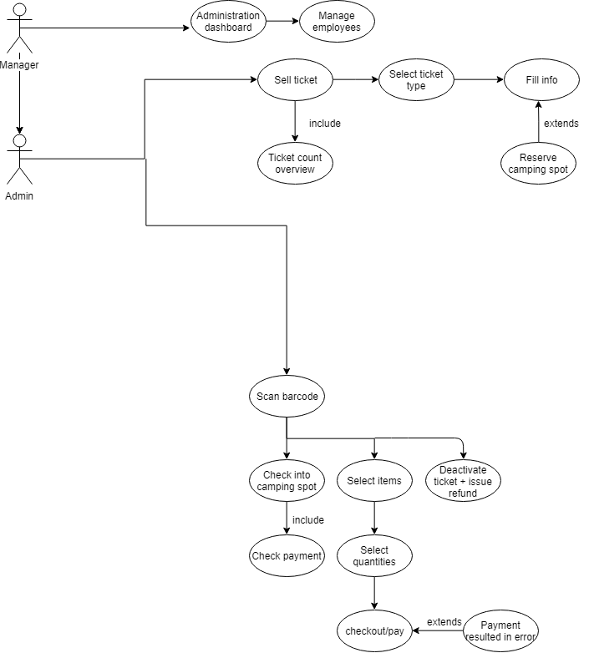

In the **website**:

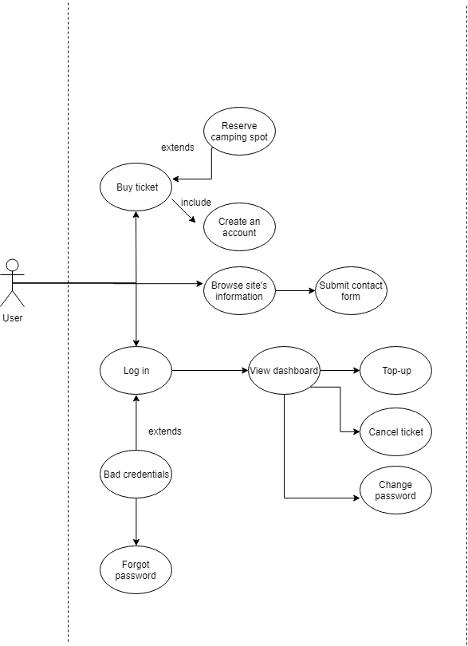

# Functional requirements

## For Website

|  |  |  |  |  |
| --- | --- | --- | --- | --- |
| **Function** | **Must Have** | **Should Have** | **Could Have** | **Will Not Have** |
| Buying individual & group tickets | x |  |  |  |
| Buying vip individual ticket |  |  | x |  |
| Reserving a camping spot with an individual ticket |  |  |  | x |
| Reserving a camping spot for group tickets | x |  |  |  |
| Reserving a camping spot for vip tickets |  |  | x |  |
| View initial balance | x |  |  |  |
| Top up initial balance with a specific amount | x |  |  |  |
| Group members (except GMaster) top up balance |  |  |  | x |
| Group members’ ability to login in (except GMaster) |  |  |  | x |
| Cancel ticket |  | x |  |  |
| Change name of person on the ticket once bought |  |  |  | x |
| Change password of the account |  | x |  |  |
| View the schedule of the event | x |  |  |  |
| Download event schedule |  |  | x |  |
| Contact the event organizer using a contact form |  | x |  |  |
| Registration and login | x |  |  |  |
| View tweets about the event |  | x |  |  |
| View activities and brief description | x |  |  |  |

## For C# application

|  |  |  |  |  |
| --- | --- | --- | --- | --- |
| **Function** | **Must Have** | **Should Have** | **Could Have** | **Will not have** |
| Category: General |  | | | |
| Switch between the different dashboards | x |  |  |  |
|  | | | | |
| Category: Tickets application |  | | | |
| Choose ticket type to buy | x |  |  |  |
| Deactivate ticket for a user | x |  |  |  |
| Generate barcodes for users at the entrance | x |  |  |  |
| Issue tickets with an additional fee | x |  |  |  |
|  | | | | |
| Category: Store application |  | | | |
| Select the quantity of food/drinks to buy | x |  |  |  |
| Make payment in order to get the items you want | x |  |  |  |
| Lend materials (flashlights, glowsticks, etc.) | x |  |  |  |
| Select the items you want to buy at the souvenir shop | x |  |  |  |
| Return Materials | x |  |  |  |
| Give receipt of purchases |  | x |  |  |
| Top up balance |  |  |  | x |
|  | | | | |
| Category: Check in/out application |  | | | |
| Check into the event at the gate | x |  |  |  |
| Check in/out of camping sites | x |  |  |  |
| Overview of un-returned materials upon checkout | x |  |  |  |
| Issue a refund (if applicable) upon check out | x |  |  |  |
| Category: Manager dashboard |  | | | |
| See the total revenue and the categories it’s divided by | x |  |  |  |
| See total visitors and the total money spent by the visitors | x |  |  |  |
| See the number of booked and open camping spots | x |  |  |  |
| See the present number of visitors | x |  |  |  |
| See charts about the revenue of each store | x |  |  |  |
| Refresh the values of the tickets sold, visitors and money spent with a button | x |  |  |  |

# GUI

Manager dashboard:

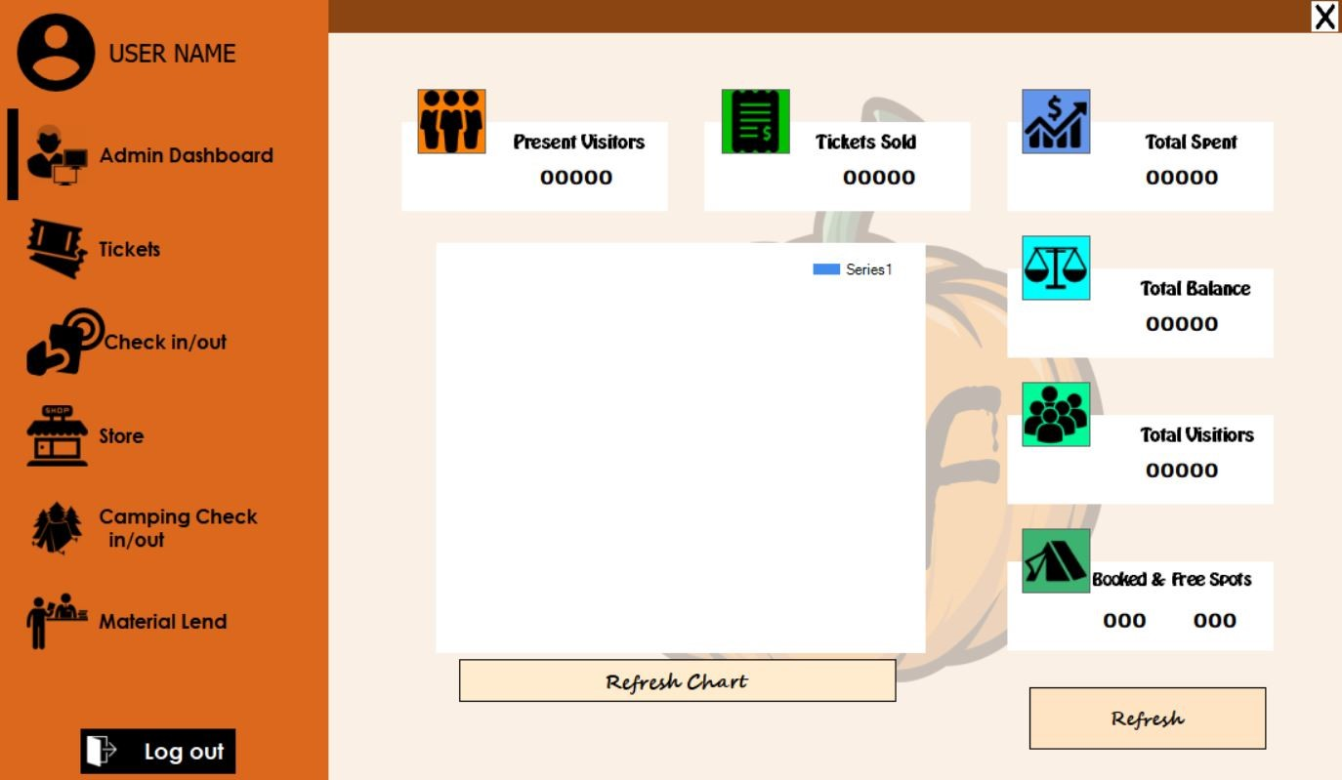

Tickets app:

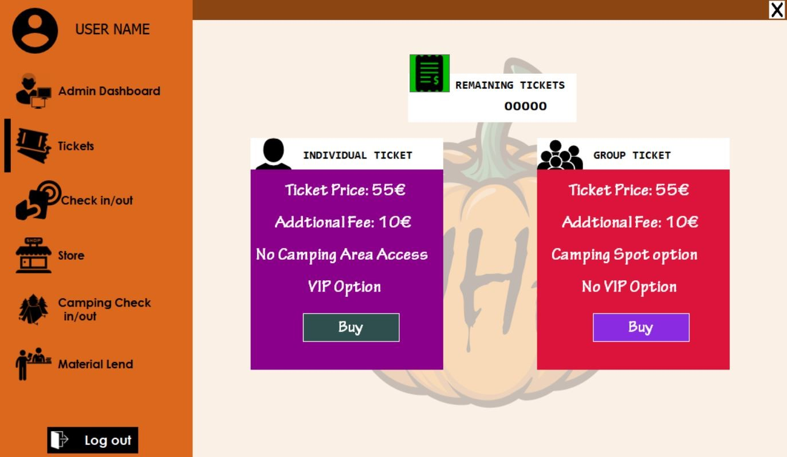

Check in/out app:

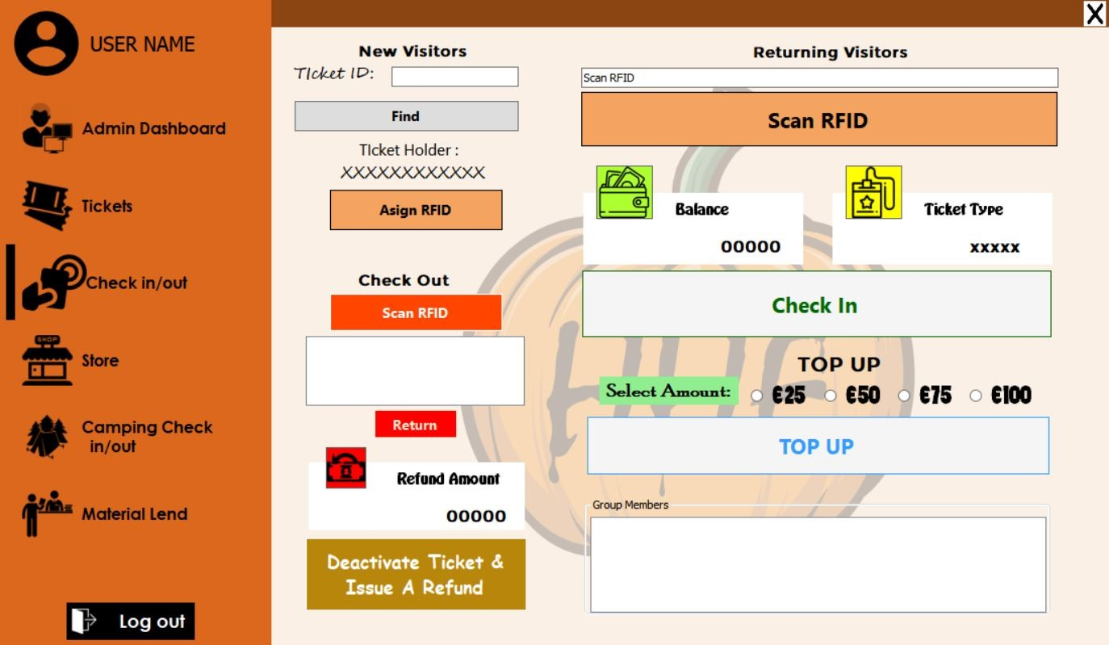

Store app:

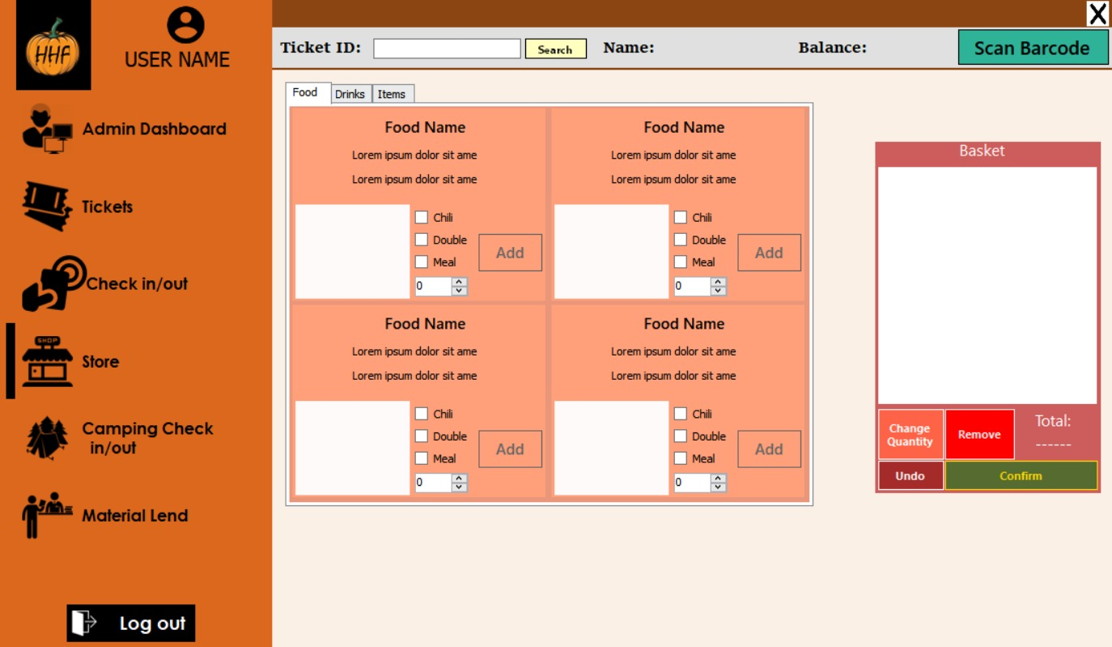

Camping checking app:

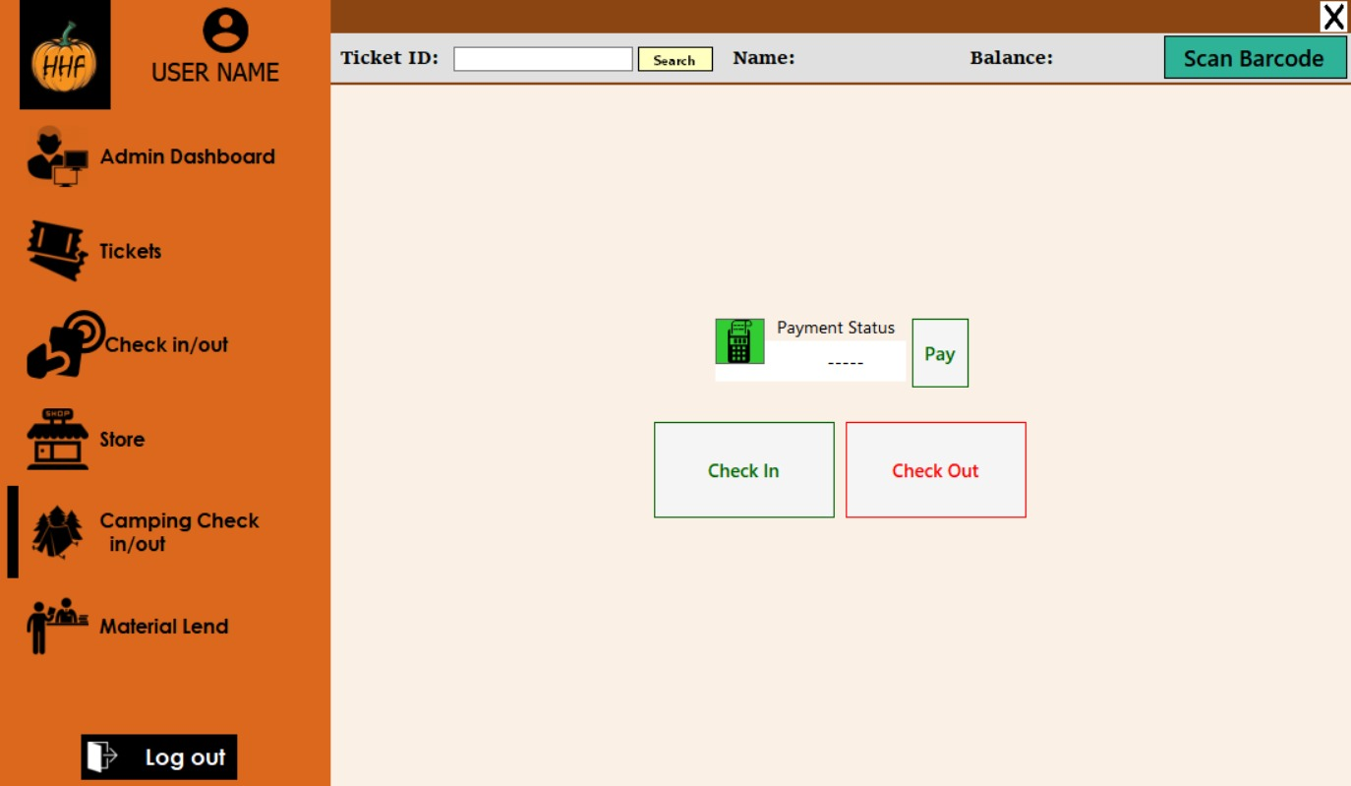

Loaning stand app:

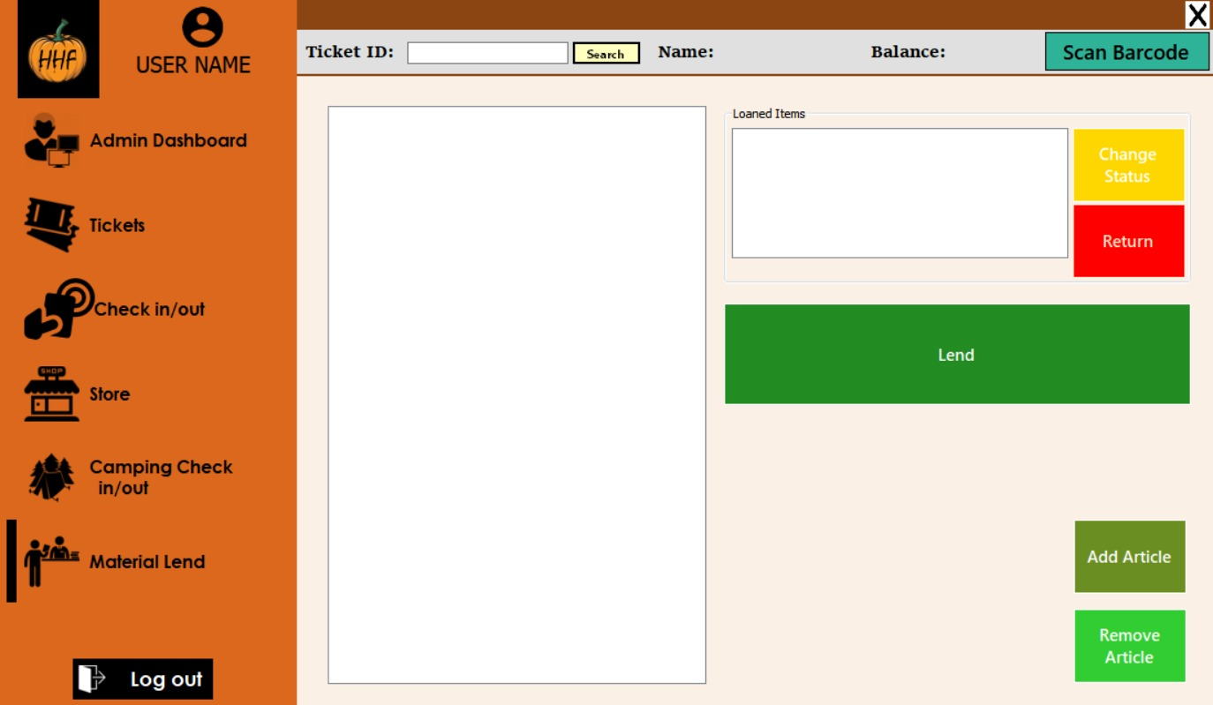

# Wireframe

Every wireframe has a brief description below it.

1. Home Page:

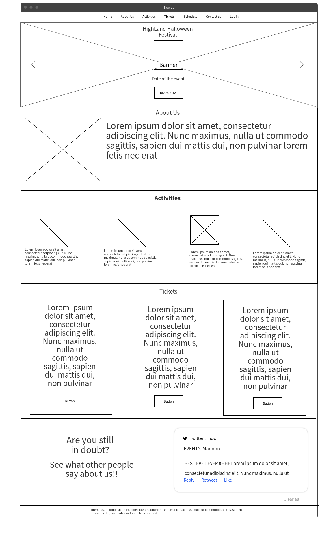

We thought that having the most important information about the event in one page makes it easier for the customers to go through everything by order and at the same time it will confuse the user while browsing the website and it will actually give a general overview of the whole event.

1. Booking form

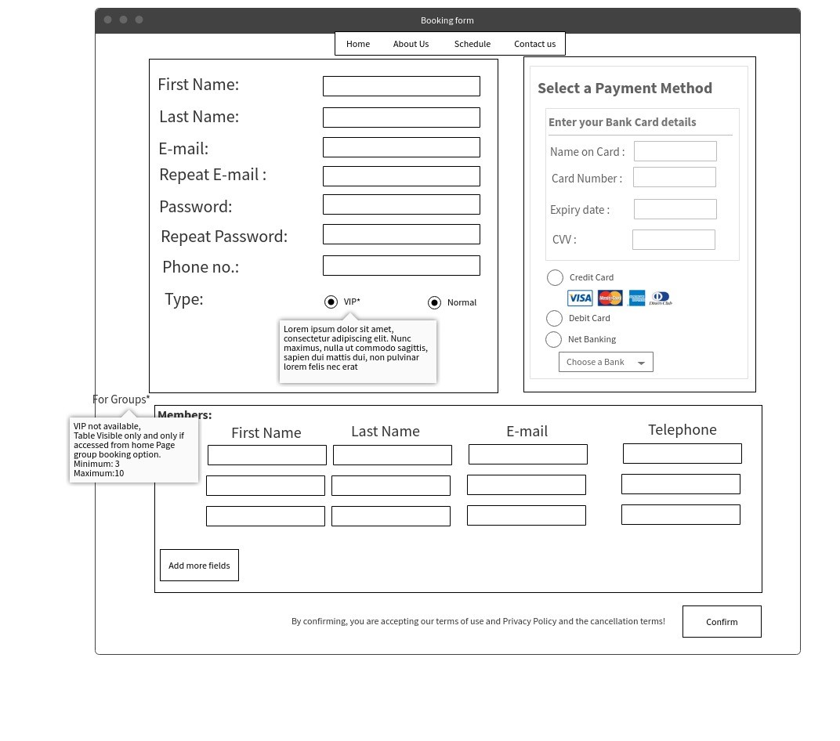

This is more of a self descriptive wireframe, although we will not have the same exact fields of input as in the wireframe but it gives a general idea about the design of the form.

1. Login Page

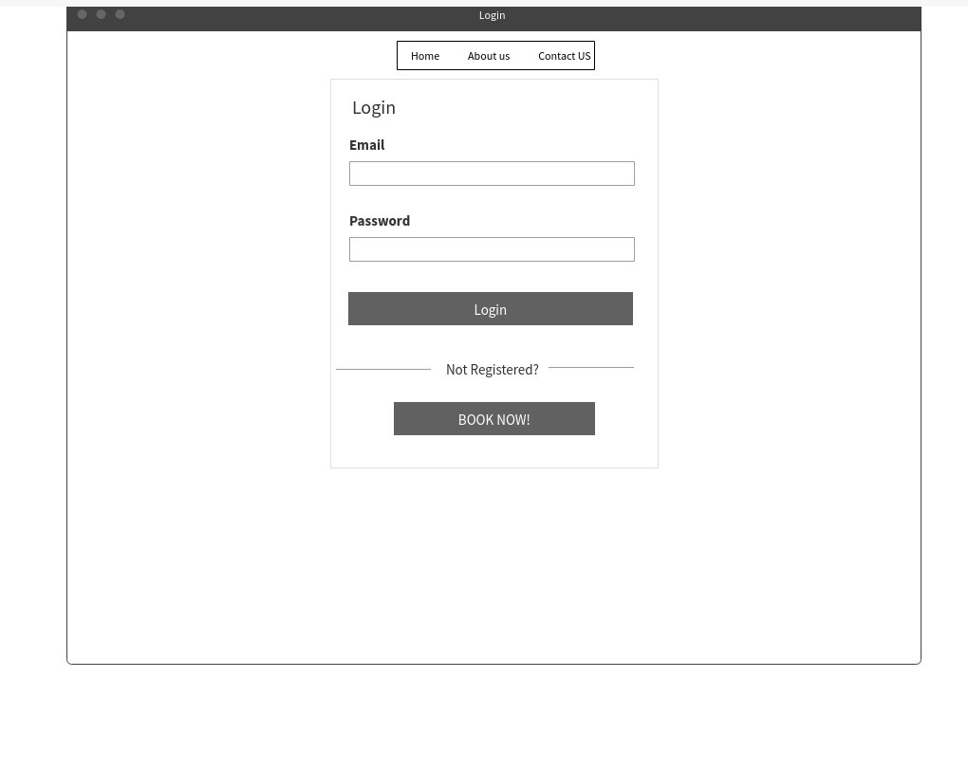

We have decided to use a basic login page with a link to book an event to be registered and able to login.

1. Schedule page

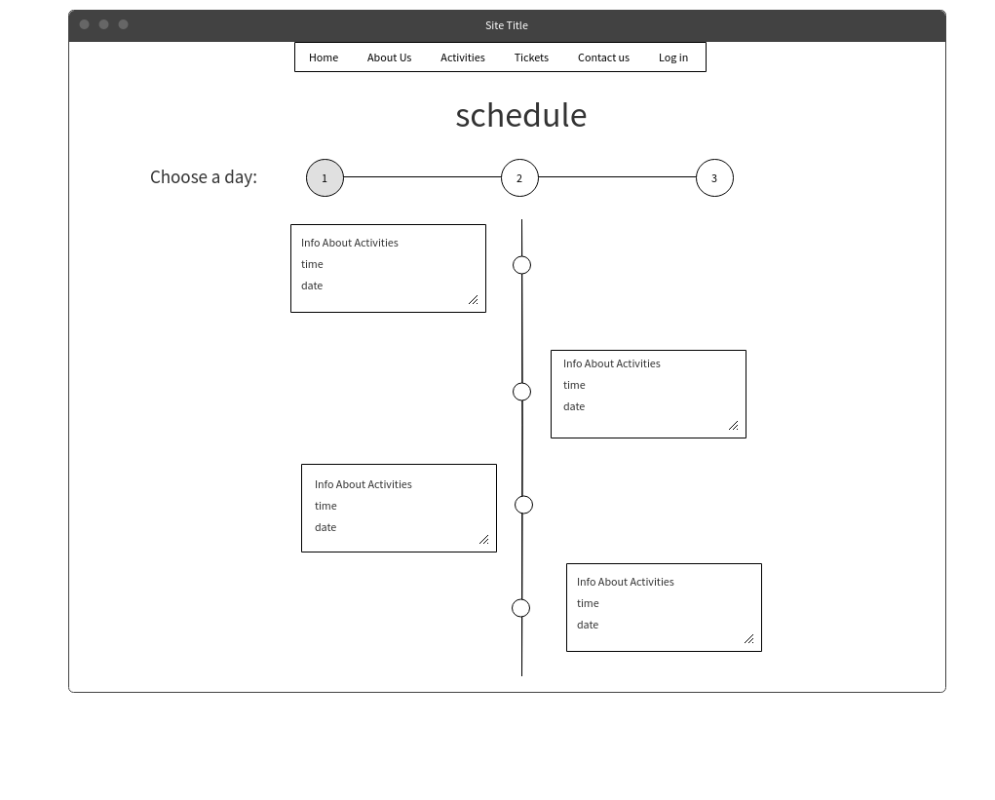

This is a timeline schedule of the event. We thought that this way of showing the schedule will be more comfortable and easier to view to the user.

# ERD

